**Heuristic Evaluation Report**

Date: 4/4/21

Prepared By (team member names): Kiauna Newman

***Evaluation***

Name of website being evaluated: n/a

Describe the scenario you used to focus your evaluation: Average Austin navigating the website.

**Problem #1**

Header/Title

Insert print screen, location of problem:

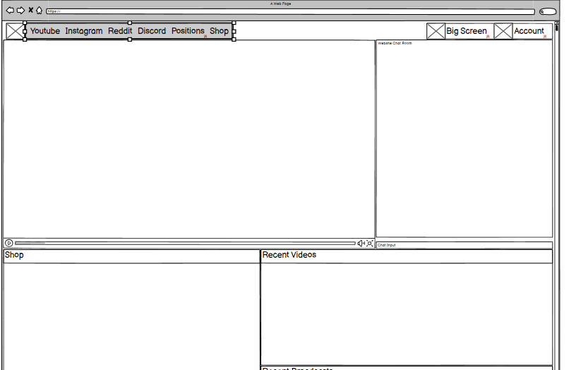

Name of heuristic: Visibility of System Status

Reason for reporting negative or positive: User should know where they are to help them understand where to go next.

Scope of problem: There is no title on the web pages that lets the User know that they are on the home, big picture, positions, or account pages.

Severity of problem (high/medium/low): medium

Justification for severity rating: When the user clicks on the big screen, position or account page, there is not a header or title that shows users what page they are on.

Suggestions to fix: Include header names for each page.

Possible trade-offs (why fix might not work): May not work due to the nature of the app, a possible trade off is adding a change of color to navigation buttons once the user has click on it.

**Problem #2**

FAQs or Help Section

Insert print screen, location of problem:

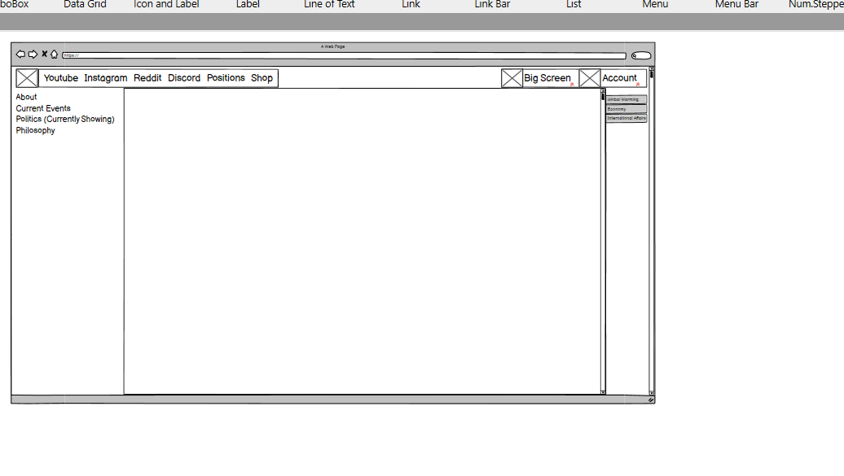

Name of heuristic: Help and Documentation.

Reason for reporting negative or positive: Users may need help navigating the site.

Scope of problem: Help section

Severity of problem (high/medium/low): low

Justification for severity rating: The targeted end user would be familiar with navigating the site and my not need any explanations. A user that is not familiar with the platform may need documentation on how to complete different tasks.

Suggestions to fix: Include a Tutorial or Help Section in the navigation menu

Possible trade-offs (why fix might not work): The user can ask questions in the web chat that is included on the big picture page.